Abstract Title (max 2 rows)
A. B. Name1,¹ (presenting author underlined); B. C. Name2,²
¹Affiliations Group or Department, University, and City
e-mail: (e-mail of the presenting author)

Please keep the original document settings of this template. Do not change the page-settings or styles.
Please use ‘Calibri’ 14 pt boldface for title, ‘Calibri’ 11 pt italics for authors, and ‘Calibri’ 11 pt normal text for the affiliations and abstract. Use square brackets for references [1,2]. Use the format indicated below for references.
The abstract must fit on a single page using this template and will be used directly for printing in the abstract booklet.
In case of graphical material (Figures or Schemes) use at least 300 dpi to increase the readability of your abstract.

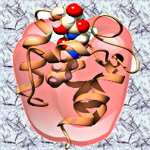

Figure 1 Example of a picture.

[1] A. B. Author, A. C. Author, Angew. Chem. Int. Ed. vol (year) first page.

[2] A. B. Author, C. Author, D. Author, Nat. Commun. 7, (2016) 12263.

Save your abstract as a Microsoft Office Word Document. Rename the file to: Lastname_Firstinitial_COST1306_Zagreb.doc and send the abstract by e-mail to nstrm@irb.hr.

Please indicate in the e-mail your preferred type of presentation, oral or poster.

